Choose a Level | WriteShop Primary

WriteShop Primary is a parent-led writing curriculum for children in grades K-3. This guide will help you choose the best starting level for your child.

Caution: Don’t Choose a Level That’s Too Young

Each WriteShop Primary level teaches specific skills within a range of ages, making it easier to choose the very best place to begin the program. However, age and skill are not the only factors. Your child’s reasoning skills, emotional maturity, and ability to express ideas orally are also important considerations. So before you decide on a level, make sure to look at the big picture!

Start at the level that best fits your child’s thinking skills, not his writing skills. A child’s ability to physically write things down often lags behind his intellect and vocabulary. For example, placing older children in Book A risks losing their interest.

Books B and C are a better fit for most 7- and 8-year-olds—even if they haven’t had much writing experience. Here’s why:
- Key concepts carry over into future books, so don’t worry about “missing” something.
- Smaller Steps and Flying Higher activities appear in all Primary and Junior books, allowing you to adjust assignments to the child’s level of ability.

WriteShop Primary Book A
Target: Kindergarten & 1st grade (and immature 2nd graders)
- Book A includes very simple concepts and artwork that appeal to little learners.
- Reading and writing skills are NOT required; all work may be done orally.
- Older children with special needs or extreme reluctance to writing may also find success with the gentle pace—as long as they are not put off by the childish worksheet illustrations.
Start with Book A if your 5- to 7-year-old is not yet able to:
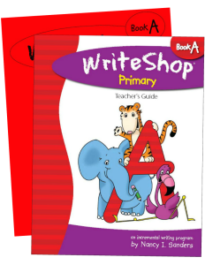
- Identify beginning, middle, and end in a story
- Orally complete predictable sentence starters
- Identify and use periods at the end of a sentence
- Begin a sentence with a capital letter
- Choose an appropriate title
- Think of simple ways to improve a story
- Read and write color words
- Recognize words that rhyme

If your child can do a number of these things already, consider choosing Book B instead.

WriteShop Primary Book B
Target: 1st & 2nd grade (or reluctant 3rd)
- Book B is a great middle-of-the-road choice when a child hasn’t had much prior writing experience. Children can dictate ideas and stories to you if their physical writing skills are still emerging. As long as they have ideas in their head and can share them orally, that’s all the skill they need to begin Book B.
- 9- and 10-year-olds with special needs may also find success with Book B if they aren’t bothered by the simplicity of the worksheet illustrations.
Start with Book B if your 6- to 8-year-old is not yet able to:
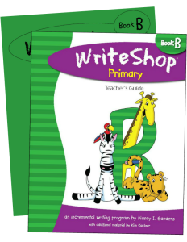
- Identify or use paragraph form and indentation
- Use graphic organizers to plan a story
- Include a beginning, middle, and end in his story
- Figure out how to add more details to a story
- Organize a story to include a problem and its solution
- Choose story endings
- Write or dictate a friendly letter
- Write or dictate about something that has happened to him
- Retell nursery rhymes and fairy tales in his own words
- Identify the parts of a friendly letter
- Identify words that rhyme
- Use standard spelling tools such as a dictionary

If your child can do a number of these things already, consider choosing Book C instead.

WriteShop Primary Book C
Target: 2nd & 3rd grade
- Book C is a good option for children who are functioning well at grade level.
- It is also a fine choice for advanced or highly verbal 3rd graders, though stronger writers might prefer WriteShop Junior Book D.
- Remember that concepts from earlier levels (such as using paragraph form and including beginning, middle, and end) will be retaught or reviewed in all future books.
Start with Book C if your 7- to 9-year-old is not yet able to:
- Plan the main ingredients of a story before beginning to write
- Ask who, what, when, where, and why? in order to add story details
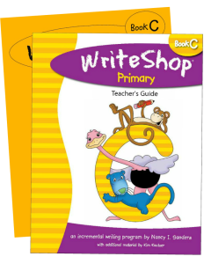
- Organize story details
- Write entries in a personal journal
- Use descriptive words in his writing
- Write a short nonfiction article
- Summarize the contents of familiar books
- Collect research facts about a specific topic
- Write a simple, short report with introduction, body, and closing
- Use standard spelling
- Check his own work for correct spelling and punctuation
If your child can do a number of these things already, consider choosing WriteShop Junior Book D instead.

